**OP 1.1.4. Optimized procedures for quality assurance and seed health management**

**RQ: How will seed health management be optimized to sustain seed yam quality and reduce seed degeneration due to virus and nematode reinfection?**

**Activity 1.1.4.1 Investigate the effect of control interventions (IPDM) on the prevention of yam mosaic virus and nematode reinfection in seed yam fields.**

**Activity 1.1.4.2. Investigate relative difference in reinfection of different seed classes and different yam varieties under protection and no-protection conditions (seed degeneration)**

Yam mosaic virus (YMV), transmitted by aphid vectors in non-persistent mode, is the most important production constraint to seed and ware yam production in West Africa. Due to the lack of host resistance in landraces or bred varieties, protecting clean seed yams from YMV reinfection by aphid vectors is crucial to prevent yield losses and seed degeneration. Trials were organized to identify methods to avoid YMV infection to clean seed yams using Dioscorea rotundata varieties, Kpamyo (TDr95/19177), and Asiedu (TDr89/02665) (Table 1). Two approaches were tested for preventing YMV transmission by aphids vectors to clean seed yams: (i) use of tall growing cereal as a barrier to interfere with aphid movement, and (ii) 3% (v/v) mineral (paraffin) oil sprays to prevent aphid feeding. Planting materials were tested by RT-PCR and PAS-ELISA to select and use only YMV-free yams for trials.

**Trial establishment:** The trial was laid out in a Latin square design comprising four treatments. (a) maize barrier + mineral oil spray; (b) maize barrier; (c) mineral oil spray; and (d) no protection (control). Each treatment has four replications as a randomized complete block design. Yam seedlings were planted at 0.2m x 1m, and each plot consisted of 8 m x 6 m (Fig 1). The trial plot was surrounded by YMV-infected yam fields, which had an incidence of 70 to 80% (Fig. 1). Seeds of *Zea mays* var. ACR 91, Suwan 1, and SRCP were received from the maize breeding Unit, IITA. These varieties were selected because of the long maturity (approx. 110 days) and tall growth (~6 feet). Maize seed was planted at 5 cm spacing in three rows two weeks ahead of yam planting (May 18-19, 2023). Virus-free yam plantlets of Var. Kpamyo and Asiedu were transplanted on 28-30 May 2023. At the time of transplanting yam seedlings to seed plots, the shortest height 18 – 63 cm, while the tallest maize stands were ranged between 38 – 97 cm (Fig. 2). The height of the maize ranged between 26 cm – 104 cm. A net of 1 m height was also placed around the maize barrier. Maize plants senescence started from the 3rd week in August and was mostly dry by the end of September. Seedlings were staked two weeks after transplanting. Yellow water traps (YWTs) were placed in each subplot to trap aphids for counting numbers trapped in each plot. YWTs were also set up in the yam fields around the trial plot as control. Yam seedlings were assessed monthly for YMV symptoms.

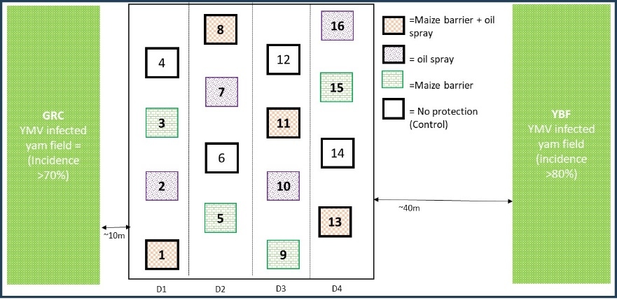

*Fig 1. Layout of the yam trial plot with the position of treatment sub-plots (maize barrier, mineral oil spray and no protection, and YMV inoculum source fields (GRC and YBF). The sub-plots were spaced at 8 mx 2 m. The planting density within the plot was 0.2 m x 1 m (seed production spacing). The numbers in each treatment plot are for reference.*

**Aphid monitoring:** Aphids were collected at 2 days intervals and total aphids were tallied up per week. Aphid counts were conducted under microscope and morphologically distinct species were grouped for DNA barcoding to confirm species identity. The count of trapped aphids was generally lower in plots with barriers than in plots with no barriers (Fig. 3). This shows that at 1 – 2 weeks after transplanting seedlings to the field, the aphid population appeared to build up significantly in exposed plots compared to the plots that had maize barrier. Furthermore, mineral oil spray treatment had little effect on the number of trapped aphids in both the barrier-protected and exposed plots. The aphid population in the nearby inoculum field (GRC and YBF) appeared to reflect the number of aphids trapped in the exposed plots compared to barrier plots. The number of trapped aphids appeared to be lower.

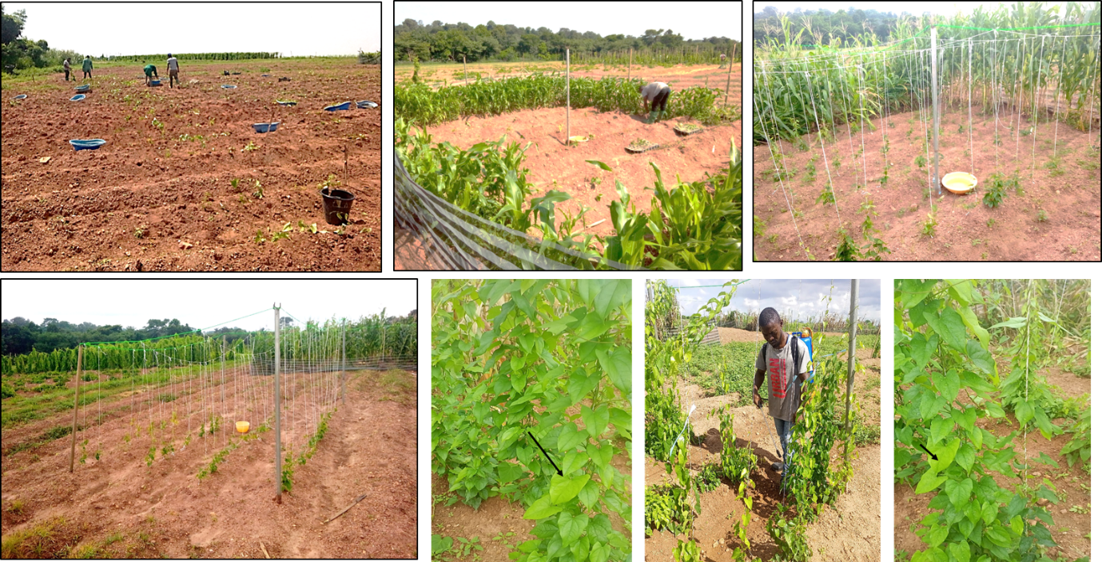

Fig 2. A and B = Transplanting of yam seedlings trial plots and maize barrier with a net; C and D = yam seedlings were staked using the trellis rope system. E, F and G=the application of oil spray to designated plots

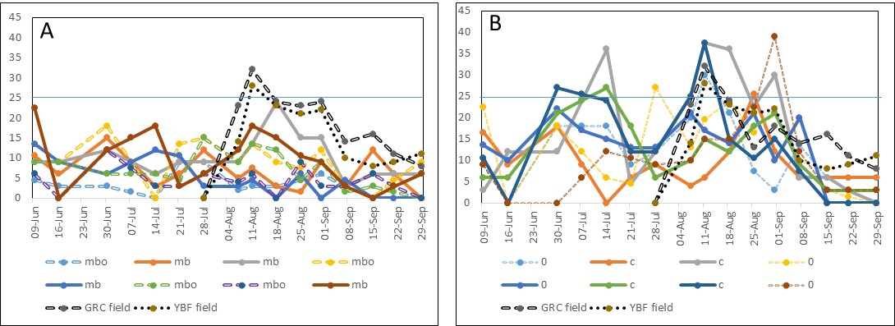

Fig. 3. The number of aphids trapped in the yellow water traps placed in each treatment plot (mbo and o), controls (c), and inoculum source (GRC and YBF) fields during the green growth stage. The collection of aphids trapped in the two inoculum source fields (GRC and YBF) was started in August 2023. A = trials with maize barrier, and B = no barrier. Mbo = maize barrier + mineral oil sprays; O = mineral oil sprays; C = no protection (control); and YBF and GRC are inoculum source fields around the trial plot used as a check.

**Virus monitoring:** Yam seedlings were assessed monthly for virus symptoms expression. Seedlings were check for mosaic and symptoms and visually symptomatic seedlings were tagged. YMV reinfection of the yam seedlings was first recorded at plots closest to the infected yam fields (10 m) (Figs. 4 and 5). However, no incidence was recorded in the plots bordering the breeding field (50 m). This shows that the distance between the seedlings field and the nearby field affects the spread of YMV to the field. Overall, at 12 WAT seedlings to yam field, YMV was generally lowest in plots with maize barrier (M+O=15±3.3%, M=13.0±3.1%) while it was highest at the exposed plots (oil spray = 44.2±3.1% and control =47±4%). One newly unfolded leaves of symptomatic yam seedlings while newly unfolded leaves of 5 asymptomatic yam seedlings were collected per plot for YMV infection using RT-PCR procedure.

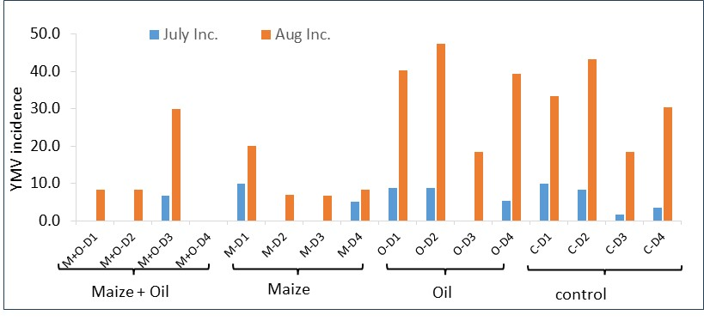Fig. 4. Incidence of YMV in different treatment plots. Maize = maize barrier, oil = mineral oil sprays, and control = no protection.

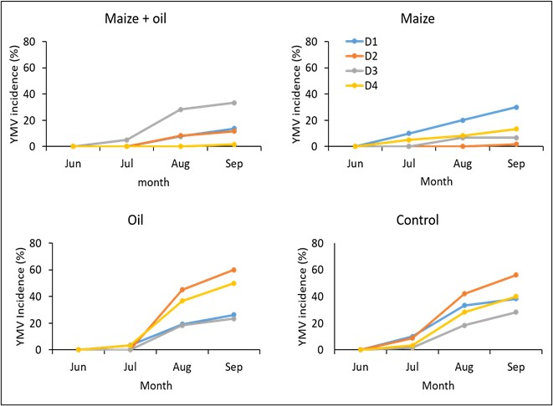

Fig 5. Plot showing the YMV incidence (mean±SE) for the different treatment (M+O=maize barrier + mineral oil, M=maize barrier, C=control (no protection); and Oil = mineral oil) for 3 months (July, August and September 2023) of assessments. B-D= shows the YMV incidence in different treatment at relative distance (D1-D4) to nearest inoculum field (GRC).

**Conclusions:** Observations are still being continued till harvest (due in January 2024). There was no evidence of aphid colonization, and YMV infection in the plots was due to the feeding/probing of migratory aphids from the neighboring inoculum field. The findings of this trial are expected to help in formulating management methods to prevent reinfection, including isolation distance to minimize YMV transmission by migratory aphids.

**Pending activities**:

* Harvesting and yield estimation.
* Testing of seed for virus infection.
* DNA barcoding to identify the aphid species trapped in the YWTs.